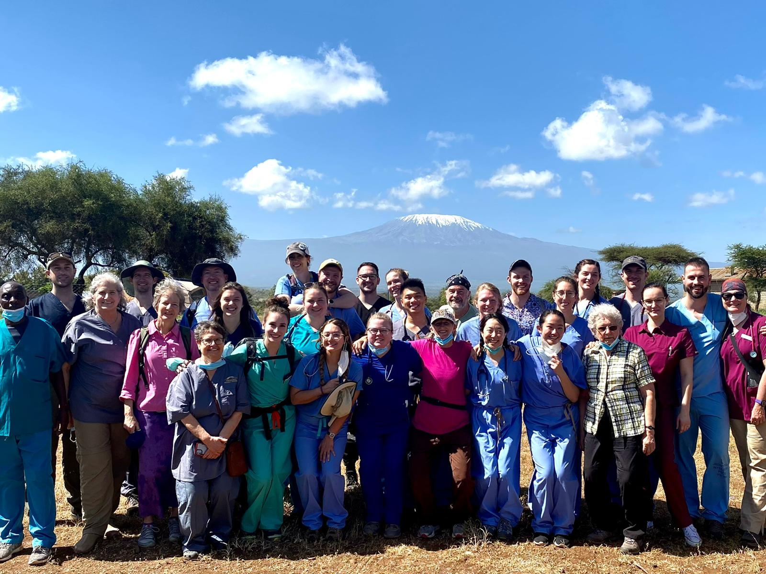

Kenya 2024
Team Meeting #3
September 11, 2023
7 – 9 pm via zoom
NOTES

- Welcome and Introduction of New Team Members – Welcome!
  - Students – Lisa Hopkins 3rd year CO, went to Nicaragua and Panama with Global Brigades, DRC, Adrianna Hammack, 4th year Rural & Wilderness Medicine Track (RWM) student, Katie Nicolich 4th year RWM.

  - Volunteers – Christy Weiland Pharmacist, has done some outreach, Madeline Miller PA, Kailey Minks high risk OB nurse, Anne Marie Lease nurse practitioner first trip, Emily Knight nurse, Brenda Rojas MA.

- About Kilimanjaro Mission Hospital – Heidi Smith shared information on Kilimanjaro Mission Hospital – see attached presentation

- Housekeeping
  - Trip Payments
August 15th Payment 1 $900 to hold your slot. First come, first served.
Sept 1st Payment 2 $1000 (Any cancellation by Sept 2nd; 90% refund)
Oct 1st Payment 3 $1000 (Any cancellation by Oct 2nd; 70% refund)
Nov 1st Payment 4 $1000 (Any cancellation by Nov 2nd; 50% refund)

  - Rooming Preferences – Let Dr. Bentley know room preferences, especially students, before the end of the month for room reservation purposes.

  - Travel Files – see end of agenda

  - Team Travel Portfolio – how to add details to the documents. Everyone, students and volunteers alike, is required to fill-in their flight information on the documents found in this folder on Teams. NOTE: the volunteer flight spreadsheet has not been posted yet. If you or your airline make a change to your itinerary, it is your responsibility to edit this document.

  - Facesheet – Please upload your preferred picture, with preferred pronouns, to your travel file (otherwise we’ll use whatever photo we can find!) - Students and Faculty, we will use your official RVU Facesheet photo, but you are welcome to upload a different photo if you prefer.

- Logistics
  - Licensing for Medical Personnel – all Kenya license applications need to be done and submitted to Samantha by the end of the month.

  - Information on Optional Safari - $1100 extra. Please let Dr. Bentley know if you will NOT be staying for that – by the end of the month. (Administrative Note: only Drs Gamundoy and Drew Rose will not be going on safari)

- Medical Presentation – Dr. Cherie, see attached

- Questions or Comments – Dr. Cherie, Cervical Cancer Screening Study - August, 2024 training 10 Kenyan healthcare workers, writing study, grant proposal going in for funding. This is in addition to and separate from the women’s hygiene project. NOTE: A specific email regarding fundraising for the Women’s Health & Hygiene project and the Beans for Bomas project coming soon. [ADMINISTRATIVE NOTE: We have our leaders for the two January projects. Student Doctors Jacoby Meyer and Tori Weingarten will head up the Beans for Bomas project. Volunteer Kim Morse and Student Doctor Kailey Sullivan will lead the Women’s Health & Hygiene project.]

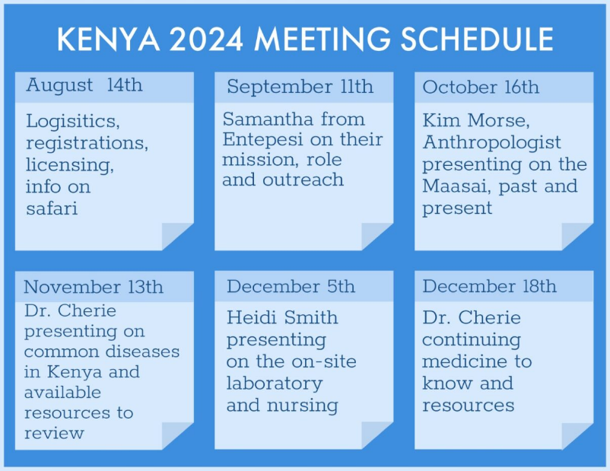
- Next Meeting – October 16
CURRENT TRAVEL FILE CHECKLISTS – Please upload documents as soon as you can. If you need a full list, this can be found in our Team files under the General tab.
Students:
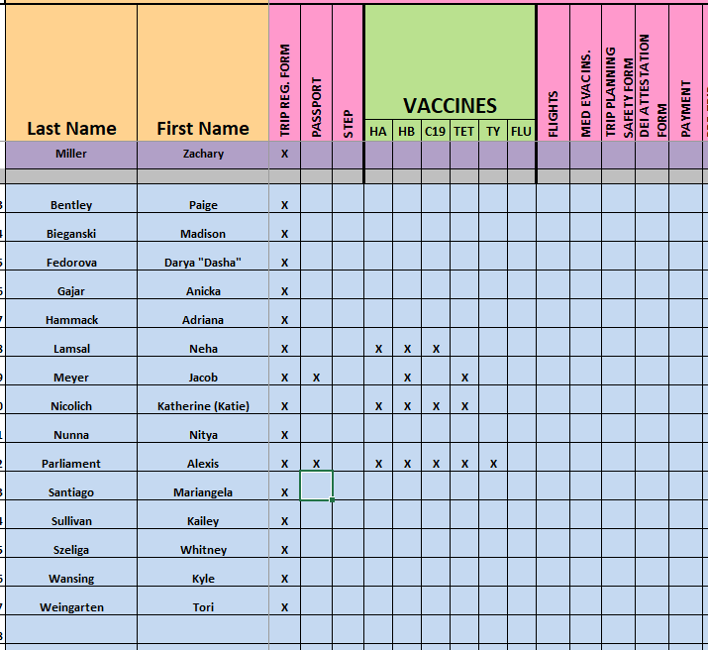

Volunteers:
